**JAVA PROJECT**

**PROJECT TITLE: VIRTUAL MOMMA**

DEERWALK INSTITUE OF TECHNOLOGY

SCHOOL OF COMPUTER SCIENCE AND INFORMATION TECHNOLOGY

SIFAL, KATHMANDU, NEPAL.

**NAME: ANIL SHRESTHA**

**ROLL NUMBER: 0101**

**CLASS:2015**

**SUBMITTED DATE:  
SUBMITTED TO:**

Table of Contents

1. 0 Abstract 3

2.0 Introduction 4

3.0 Research Question / Topic 4

4.0 Methodology/Process 4

5.0 User Interface 5

6.0 User Story 7

7.0 Database 8

8.0 Technology 8

9.0 Feasibility Analysis 9

9.1 Technical feasibility 9

9.2 Economic feasibility 9

9.3 Operational Feasibility 9

9.4 Legal Feasibility 9

10.0 Conclusion 9

11.0 Bibliography 9

# 

# 1. 0 Abstract

Cooking is one of the passion. Anyone can cook with the well documented recipes. Among different recipe applications this paper discuss about Virtual momma, web application targeting to solve the problems of undocumented local recipes so that people can interact on the basis of recipes, sharing recipes ,inviting friends for dinner or lunch.

This documentation discuss about how the solution to the problem can be achieved with the user friendly interfaces and how to cook on the basis of shared recipes ensuring the same taste that one have tasted.

# 2.0 Introduction

# Virtual momma as the name suggest is one's virtual mom. It will teach user how to cook same food that the user have tasted in relative's house or in friend's house referring to recipe that is shared by that friend. In this application interaction with nearest and dearest one is on basis of recipe. User can add friends to their circles, accept friend request, can add as well share their recipes within their friend circles or publicly. User can invite those friends for dinner or lunch who are the most admirer of that recipe. Likewise user can upload photos of finished dish, photos having fun with friends in dinner. User can view the recipe shared by their friends whereas in the meantime they can add that recipe to their favorites list so that they can cook that food in their leisure time.

Simple and well documented recipes will guide users throughout their cooking time ensuring that inherits the taste as they have tasted.

# 3.0 Research Question / Topic

One always get served with special food in friend's home, his/her friend will tell recipe but still s/he will not be able to cook as tasted, as s/he forgot ingredient's name, some process or might be due to no perfect recipe documentation.  
  
So it will mainly focus on how to solve this problem with the help of web application.

4.0Methodology/Process  
There are numerous recipes popular among every Nepalese peoples. Newari recipes are even best, most of the people loves Newari foods. Not only Newari recipes there are many other popular recipes depending upon the caste and cultures. But the main problem is that peoples have no way to try that recipe on own. Not only on the basis of caste every house in the Nepalese society have one distinct recipe that have its own charm among the guest. The problem is again people cannot try that recipe on own even they try they could not give it with that best taste due to lack of proper recipe documentation. So that Virtual momma will help solving such problems, it will act as one perfect platform to add the recipes and share the recipes. How it can be the perfect platform? How it can address the existing problem? The solution to the problem can be achieved as:

# 5.0 User Interface

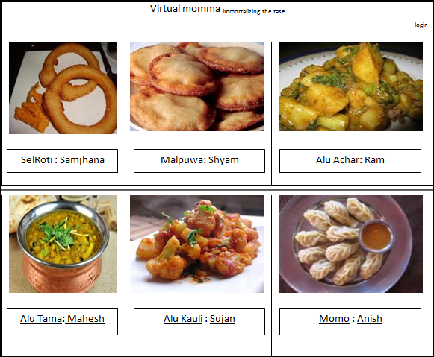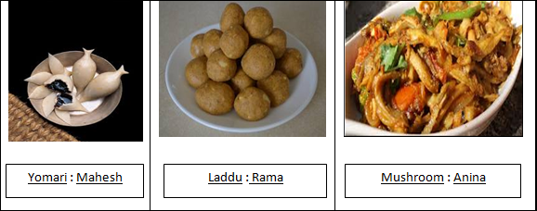

Fig\_1: Landing page of Virtual momma

## newsf.PNGAddrecipe final_now.png

Fig\_3: Add Recipe page

Fig\_2: News Feed page

## Invitation.PNG

Fig\_4: Invitation for dinner/launch page

# 6.0 User Story

1) User lands in the landing page as shown in the above Fig\_1. Those who have shared the recipe publicly is displayed randomly. Without login user can read recipe by clicking the recipe name but to view the profile of the other user, user have to log in.

2)With successful login user lands on News Feed page as shown in Fig\_2. Welcome text is displayed with respective user name. Notifications tab is for notifying the user about shared recipes and requests. Friends tab is for displaying the list of friends of user. Friend's activities is displayed in own news feed.

3) Clicking Add recipes lands user to the Add Recipe page as shown in Fig\_3. User inputs recipe name in the given textbox, Ingredients name in the given textbox, Ingredients quantity in the given textbox, the unit of the quantity are already defined, user have to choose one of them and click Add to list button which automatically saves ingredients in database and redirects to ingredient textbox clearing the ingredient and quantity textbox.

User list down the recipes point wise. With clicking Add button it is saved in the database as well it is automatically saved in user's Add to Favorites. User can share the recipe choosing the public or friend option with or without attaching the image of recipe.

4) Clicking Invite button lands user to the Invitation for dinner/lunch page as shown in Fig\_4 displaying all list of friends. User chooses type of invitation, recipe name and check the checkbox of respective friends and click invite button. The invitation notification is sent to those selected friends of the user.

5) User can post about what they are learning to cook or about the cooking experiences.

# 7.0 Database

|  |
| --- |
| **User** |
| UserID |
| FirstName |
| LastName |
| Email |
| Password |

|  |
| --- |
| **recipe** |
| recipeID |
| recipeName |
| recipeStatus |
| UserID |

|  |
| --- |
| **Ingredient** |
| recipeID |
| ingredientID |
| ingredientName |
| quantity |
| unit |

|  |
| --- |
| **User\_Friends** |
| UserID |
| FriendID |

# 8.0 Technology

* Java Servlet.
* MySQL.

# 9.0 Feasibility Analysis

## 9.1 Technical feasibility: The application is technically feasible. One having knowledge of java can code for building web application. The developer can easily analyze the required hardware and software in order to build the web application.

## 9.2 Economic feasibility: The application is economically feasible. Any person with Java EE knowledge can build it.

## 9.3 Operational Feasibility: There will be no difficulty in using the application to those user who are already using social networking sites or to those who are beginners as the application will be user friendly.

## 9.4 Legal Feasibility: The application will be legally feasible. As the user uploads the recipe on the basis of their interest there will be no legal problems.

# 10.0 Conclusion

Through this documentation it is shown how the undocumented local recipes can be properly documented and shared to other user with the help of web application. How they can be added, shared and how the invitation can be sent to those friends who are the real admirer of the recipe.